CSE 381– Image Processing

Project Phase 1 Report
3/12/2025



Submitted by:
Ayham Sameh 23P0285
Ahmed Wail 23P0335
Youssef George 23P0227
Shehabeldin Ahmed 23P0201
Zeyad Ahmed Hamdy 23P0082

Pre-Processing Steps:

Slicing

Goal: To Extract Features better and get boundaries of each piece separately.

Technique Used: Grid Slicing using (height & width of image)/no. of puzzle pieces in same dimension

Denoising

Goal: To Make Flat bulks similar to each other and smoother while preserving color and edges information.

Techniques Used:
- Non-Local Means Denoising
  - Denoises by comparing similar patches across the image, so it smooths noise while preserving the real edges and colors.
  - Cons: It is slower and can slightly over-smooth flat areas, but it is still the best among all options, so we chose it
  - Failure Cases: Some images have thin edges but other than that the produced images have the details needed for matching
- Bilateral
  - It smooths the image while keeping edges sharp by only blending pixels that are close and similar in color.
  - Cons: It can still slightly change edges and sometimes creates a small edge glow around borders. It is comparable to the NLM technique but for the problem at hand we decided that NLM is better suited because of how it works
  - Failure cases: similar to NLM
- Gaussian
  - Gaussian Blur replaces each pixel with a weighted average of its neighbors.
The weights follow a Gaussian curve: closer pixels matter more, farther ones less.
  - Cons: It blurs edges, even important puzzle boundaries & smooths everything equally, so can’t identify noise from structure.
  - Failure cases: It blurred images too much that the textures and details got blended which made matching accuracy when we tested it so low
- Median
  - The median filter replaces each pixel with the median value of its neighborhood Instead of averaging, it sorts the pixel values and picks the middle one.
  - Cons: It changes the small details & colors and only works well for one type of noise (Salt & Pepper)
  - Failure cases: It interpreted non repetitive textures, which occur a lot in the dataset, as noise and pepper which caused these textures to be flattened and some noise to appear

Enhancement

Goal: To convert improve local contrast, identifying subtle texture details without distorting color information and try to make object outlines more explicit.

Techniques Used:
- CLAHE
  - It converts image into small tiles, performs histogram equalization on each tile, limiting the contrast to prevent noise amplification as it redistributes intensity in each tile separately, which suites out current dataset which has lots of information which needs careful handling to avoid introducing more noise so we chose it
  - Cons: It requires careful tuning of the tile grid size
  - Failure Cases: The contrast in some areas was a bit off but overall, the images produced have the details needed for matching
- Standard Histogram Equalization
  - Stretches the intensity range of the entire image to cover the full spectrum from black to white
  - Cons: Because it works globally, it may mess up some details like very dark or bright areas and can cause abrupt changes.
  - Failure cases: Some edges had strange batches especially around the boundaries
- Laplacian Filter
  - Adds a high-pass filtered version of the image to itself to make edges appear sharper
  - Cons: forces gradual transitions to become abrupt step changes, destroying the gradient information which we rely on in our matching algorithm.
  - Failure cases: This gave us the worst results as colors were extremely distorted and details were completely destroyed

Sample Output

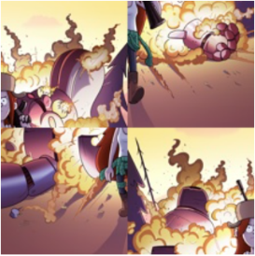
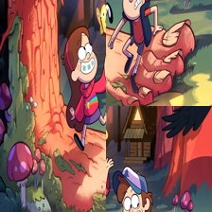
Before After








Github Link

Link

